## Image OCR regions

### Camera 134

1

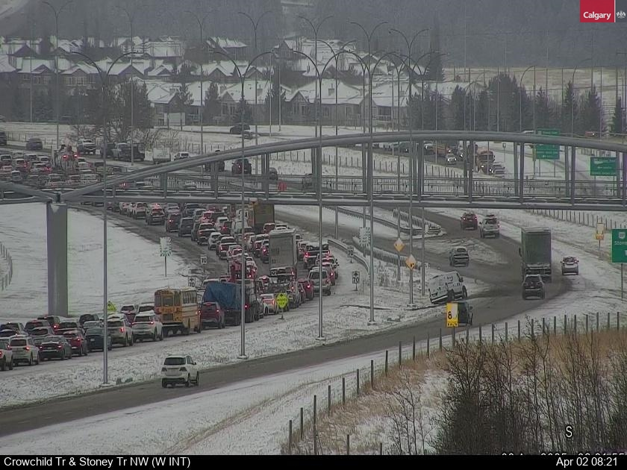

31

2

|  |  |  |  |  |  |
| --- | --- | --- | --- | --- | --- |
|  | Desc | X1 | Y1 | X2 | Y2 |
| Image | Camera Image | 0 | 0 | 840 | 630 |
| 1 | Location | 0 | 600 | 350 | 630 |
| 2 | Date_Time | 720 | 600 | 830 | 630 |
| 3 | Orientation | 750 | 560 | 780 | 600 |

### Camera 015

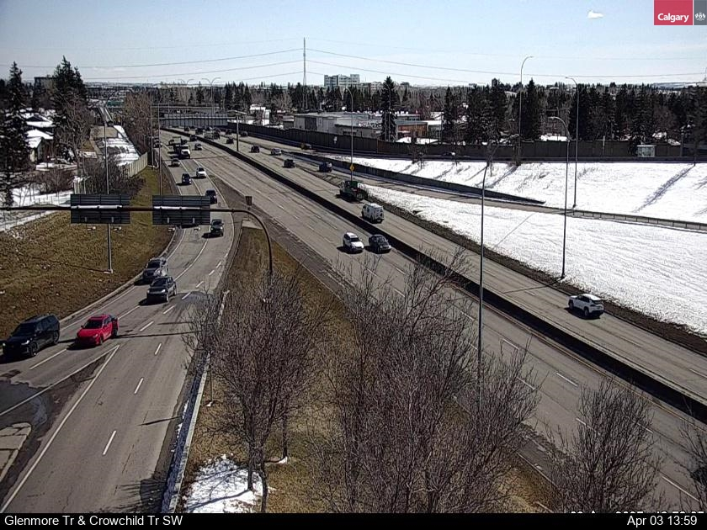

Camera 015 does not have an orientation region, error trap for this.